Analysis part:
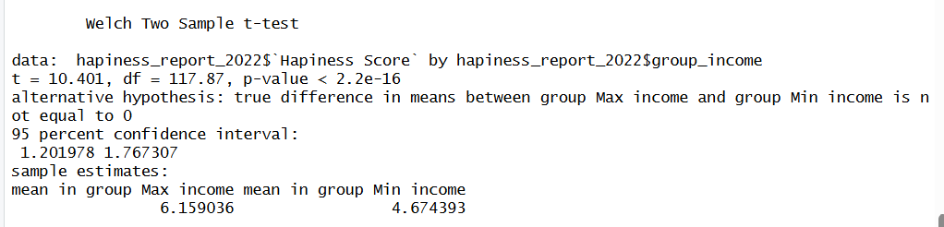

4.1. Statistical test used to test the hypotheses
The independent samples t-test was used to compare the mean happiness scores between the two income groups. This test is appropriate because the research question aims to examine mean differences between two independent groups (Max income vs. Min income). The dependent variable, Happiness Score, is continuous and measured on an interval scale, while the independent variable is nominal. With a reasonably large sample size and approximately normal distribution, the t-test is suitable for this analysis.
4.2. Interpretation and decision on null hypothesis
The results of the t-test indicate a statistically significant difference in happiness scores between the two income groups, t(117.87) = 10.40, p < 0.001. Because the p-value is far below the 0.05 threshold, the null hypothesis — stating that there is no difference in mean happiness score between income groups — is rejected. The Max income group had a notably higher mean score (M = 6.16) compared to the Min income group (M = 4.67). This suggests that countries with higher income levels tend to report substantially greater happiness on average.

